

Date: 18-10-2012

Version: 1.2

Instructions for
technical requirements for casinos

Standard Records
SAFE
Tamper Token

Gambling Control System
2012

Document history:

Version | Date | Description of changes
1.0 | 2012.09.01 | Published official version.
1.1 | 2012.09.10 | Updated version of Standard record XSD schema – casino – 10sep2012.zip: The element SpilCertifikatIdenfikation has been corrected to SpilCertifikatIdentifikation in the structures KasinoSpilleautomatTransaktionStruktur and KasinoSpilleautomatJackpotStruktur.
1.2 | 2012.10.18 | - Paragraph 5.3 inserted.  - The following requirement has been removed from paragraph Error: Reference source not found: ”Each casino must use the structure to report data on local jackpot pools”. This information was also provided by e-mail to licence holders on 19. september 2012.  - Paragraph 2.4 inserted.

Table of contents
1. Purpose 4
2. Standard Records 5
2.1. Conceptual model 5
2.2. XSD schemas for Standard Records 5
2.2.1. Schema for casino gaming machines (AWP) 6
2.2.2. Schema for jackpot games on casino gaming machines (AWP) 6
2.3. Release process for Standard Records 6
2.3.1. Major releases 7
2.3.2. Minor releases 7
2.4. Handling of errors in reported data 7
3. SAFE 8
3.1. Folder structure on SAFE 8
3.2. SAFE configurations 9
3.2.1. Naming standards 9
3.2.2. Packing of files 9
3.2.3. Choice of date-folder for zip-file 10
3.2.4. UTC time for SAFE 11
3.2.5. Zip-files must be completely packed and transferred before calling TamperTokenLuk 11
4. Tamper Token 12
4.1. Tamper Token: Webservice description, WSDL- and XSD-files 12
4.2. General technical configurations 12
4.2.1. Header information and error handling 12
4.2.2. Service call – creation of http(s) connection and receiving data 14
4.3. Tamper Token configurations 14
4.3.1. Error handling for Tamper Token Hent service 14
4.3.2. Error handling for Tamper Token Luk serivce 15
4.3.3. Mechanism for MAC generation 16
4.3.4. MAC API 17
4.3.5. MAC algorithm – figure 19
4.3.6. Example of MAC calculation 20
4.3.7. Handling unused tokens 20
4.4. Examples of Tamper Token service request and reponse 21
4.4.1. TamperTokenHent 21
4.4.2. TamperTokenLuk 22
5. Licence Holder’s quality assurance 23
5.1. Schema validation of Standard Records with XML Spy 23
5.2. Validation of correct Tamper Token MAC calculation 23
5.3. Tool for validating standard records 23

Purpose

The purpose of this document is to provide casinos (hereafter the Licence Holder) with an overview of the technical requirements to comply with when connecting gaming machines (AWP) to the central monitoring system. The document contains all the requirements with the purpose of providing a better overview of the technical requirements and the documents and files, which elaborate the requirements.
The individual sections contain descriptions of the requirements to be met by the Licence Holder in relation to Standard Records, SAFE and Tamper Token. Furthermore, the document contains suggestions to the quality control made by the Licence Holder.

Standard Records

Licence Holder must report data in a data format called Standard Records specified by the Danish Gambling Authority (DGA). Standard Records are XML structures which are constructed based on elements which are explained in a conceptual model. The conceptual model is described in more detail in section 2.1. The specification of the exact xml-structures are explained in section 2.2 with reference to the XSD schemas. Standard Records for casinos consist of only one structure. Description of the structure and how it is used can be found in section 2.2.1.

Conceptual model

The conceptual model should be considered a meta-model of the data elements which are used in Standard Records. The purpose is to explain the logical connections and to explain the data elements and their data types. The model is not a database model. The DGA should not have access to a database, but retrieves all data as Standard Records packed as zip-files on the Licence Holder's SAFE.

The conceptual model is found as a separate document on the DGA’s website.

Documents and files
Begrebsmodel Standard Records – Kasino – 01sep2012.pdf
Begrebsmodel Standard Records – Kasino – english – 01sep2012.pdf

XSD schemas for Standard Records

The DGA has specified a XSD schema for the Standard Record the Licence Holder must use. The schema is found in the file mentioned in the table below. The zip-file contains the following folders:

- view: contains the XSD file which specifies the type of Standard Record
- types: contains the different data types, which are used in the XSD schema
- class: contains the XSD classes which are containing all the elements, which are used in Standard Records

Licence Holder must follow the schema strictly. This means that Licence Holder must report all data in the specified schema. It is a requirement that Licence Holder reports data which are schema valid and that no data is left out. If Licence Holder is in doubt of the use of the XSD schema, the Licence Holder must contact the DGA.

Documents and files
Standard record XSD schema – casino – 10sep2012.zip

The DGA has generated example files for illustration of Standard Records. The example files are generated automatically and illustrate syntax and data types. The actual content of each attribute is described in the conceptual model.

Documents and files
Standard record examples – casino – 10sep2012.zip

Schema for casino gaming machines (AWP)
The DGA requires that the Licence Holder reports data from gaming machines (AWP) in one structure. The information must be reported in the standard record KasinoSpilleautomatTransaktionStruktur.

If a gaming machine is switched off, data may not be delivered in the period where the gaming machne is switched off. Timer reporting must begin again, when the machine is switched on.

Name of structure | Description
KasinoSpilleautomatTransaktionStruktur | Counter reading must be delivered in the structure every hour.

Schema for jackpot games on casino gaming machines (AWP)
The DGA requires that the Licence Holder reports data from jackpot pools which are connected to gaming machines (AWP). The information must be reported in the standard record KasinoSpilleautomatJackpotStruktur.

The information on Casino Danmark Jackpot must only be reported by Casino Copenhagen. This also includes the fields on added amount (”SpilleautomatJackpotTilvækstBeløb”) to the jackpot pool from each gaming machine connected to the jackpot.

Name of structure | Description
KasinoSpilleautomatJackpotStruktur | The structure must be delivered in the following situations:  - every hour  - when the price pool is won  - when a new pool is started

Release process for Standard Records

The DGA will update Standard Records as needed. This could be in order to ensure high data quality, to extend the controls which the DGA performs or to implement suggestions from the Licence Holders.

Updates to Standard Records will be divided into major and minor releases.

Major releases
Major releases will be changes to Standard Records, where a larger effort from Licence Holder is expected. Major releases will not be backwards compatible and an effort from all Licence Holders will be necessary to adjust to the new release.

A major release will be announced beforehand on the DGA’s website. Licence Holder will have good time for implementing the changes, where the time will depend on the number of changes. The DGA will communicate a cut-over date where the earlier version of Standard Records are no longer valid, and each Licence Holder must therefore use the new version of Standard Records from this date. It will not be possible for a Licence Holder both to report in a new and an old version of Standard Records at the same time.

Licence Holder must ensure that there are no data errors when the cut-over is performed, e.g. through a thorough test.

Minor releases
Minor releases are smaller changes to Standard Records, which are backwards compatible. This could be extension of data domains, addition of optional elements, etc.

Minor releases will not be announced beforehand and will be announced on the DGA’s website from day to day. Minor releases will not necessarily affect all Licence Holders, but the Licence Holders for who the minor release is relevant must quickly adapt to the new version. A cut-over date may be set for specific Licence Holders for who the release is relevant, but it might not be a cut-over date which applies to all Licence Holders.

Similarly to major releases, Licence Holder must ensure that there are no data errors by the transition to a new minor release. However, the amount of testing will most likely be less than for a major release.

Handling of errors in reported data

If the Danish Gambling Authority or Licence Holder should discover errors in data after 1. january 2013, then Licence Holder must correct the errors and re-send the involved data by packing data with a new token and placing the data on SAFE.

SAFE

SAFE is Licence Holder’s data storage for Standard Records. More information on SAFE may be found in the document on “Technical requirements for casinos...” on the DGA’s website.

Typically, each Licence Holder will have one SAFE. However, the DGA may approve several SAFEs per Licence Holder. If the Licence Holder wish to report data in on multiple SAFEs, the Licence Holder must contact the DGA with the number of SAFEs and explanation. The DGA will provide at least one username for the Tamper Token system per SAFE.

In the following is described the required folder structure on SAFE as well as other SAFE configurrations.

Folder structure on SAFE
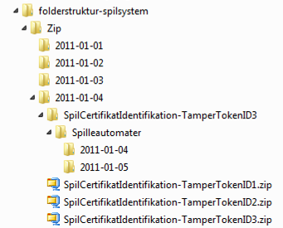
The Licence Holder must build the SAFE based on this structure:

Level 1: The outermost folder should be named “folderstruktur-spilsystem”.

Level 2: Here is one folder named “Zip”.

Level 3: Here are folders for each day, named after the date in the format YYYY-MM-DD.

Level 4: Here are a number of zip-files, where each is connected to one token. There are also folders for the tokens which are not yet closed. A folder which has not has been closed yet is named SpilCertifikatIdentifikation-TamperTokenID. The zip-file which contains the folder is named SpilCertifikatIdentifikation-TamperTokenID.zip.

Level 5: Here are the folders each zip-file contains. For casinos there must be one folder named: “Spilleautomater”.

Level 6: Here are folders for the relevant dates, named after the date in the format YYYY-MM-DD. Each Standard Record is placed on this level or level 7, and is placed in the folder that matches the time where the file is created.

Level 7: [Optional] There is a possibility for creating subfolders containing time intervals in the format HH.MMHH-MM.

XML-files must be placed in the folder with the date that represent the creation of the file.

SAFE configurations

For the DGA to find and retrieve the right data on SAFE, certain configurations must be in place in relation to naming and packing of files.

Naming standards
All files on SAFE must follow the naming standard provided below. This applies both to Standard Record files and zip-files.

Standard record files must be named: SpilCertifikatIdentifikation-TamperTokenID-SequenceInToken.xml.
The zip-files must be named: SpilCertifikatIdentifikation-TamperTokenID.zip.

Here is:
SpilCertifikatIdentifikation: Text string provided by the Danish Gambling Authority to the License Holder during the connection process.
TamperTokenID: Identification of each tamper token which is received by calling the service operation TamperTokenHent in the service TamperTokenAnvend.
SequenceInToken: A serial number, running from 1 and ended with E for ”End” (1, 2, 3,…,E) to indicate the sequence of which each Standard Record is included in the MAC algorithm for each token. It is the License Holder’s responsibility to build a mechanism for generation of the sequence.
If a zip-file only contains one xml-file, this xml-file can have SequenceInToken value 1 or E. Both possibilities are valid.

Example:
If SpilCertifikatIdentifikation=12345, TamperTokenID=67890 and SequenceInToken=3 for a specific Standard Record file, the Standard Record file must have the following name 12345-67890-3.xml. The zip-file which contains this Standard Record must have the file name 12345-67890.zip.

Packing of files
To save disk space for the License Holder and to simplify the transfer of files, the Standard Record files must be zipped in a continuous process when they appear on SAFE. How they should be zipped is explained in the following.

When the Standard Record files for a token arrives, the following should happen:
- The MAC algorithm is run on each file as described earlier in this document.
- The Standard Record is saved in the folder structure for the present token.
- The Standard Record is appended the zip-file for the present token.
When the token is closed and all Standard Record files are added to the zip-file, the folder which matches the zip-file should be deleted. It is the License Holders task to build a mechanism to secure that these three steps are conducted correctly.

The following contains an example: On the figure below it is illustrated that the folder 2011-01-04 has two closed tokens which is associated to the zip-files: SpilCertifikatIdentifikation-TamperTokenID1.zip and SpilCertifikatIdentifikation-TamperTokenID2.zip, and one open token which is associated to SpilCertifikatIdentifikation-TamperTokenID3.zip. It can be seen that SpilCertifikatIdentifikation-TamperTokenID3.zip is open since there is both a zip-file and a folder structure with the same name. The Standard Records appearing continuously and is associated to token 3 should be saved in the folder SpilCertifikatIdentifikation-TamperTokenID3 and appended to SpilCertifikatIdentifikation-TamperTokenID3.zip. When token 3 is closed and all Standard Records are added to the zip file, the folder SpilCertifikatIdentifikation-TamperTokenID3 should be deleted.

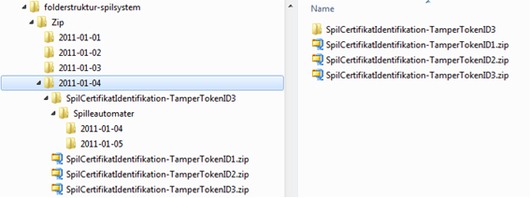

Choice of date-folder for zip-file
As described in the section above, the zip-file must be placed under level 3 in the folder structure on SAFE. Level 3 consists of folders with dates, and the zip-file must be placed under the correct date.

The zip-file must be placed under the issue-date which is valid for the token. The issue-date is found in the response from the serviceoperation TamperTokenHent and is the first 10 characters of the element TamperTokenUdstedelseDatoTid.

In the example below is given the value 2011-10-16T15:21:19.221+02:00 in the element TamperTokenUdstedelseDatoTid. The zip-file, which is build using this token, must therefore be found on SAFE under the path folderstruktur-spilsystem/Zip/2011-10-16/.

<env:Envelope xmlns:env="http://schemas.xmlsoap.org/soap/envelope/">
<env:Header/>
<env:Body>
<ns:TamperTokenAnvend_O xmlns:ns="http://skat.dk/begrebsmodel/2009/01/15/">
<ns:Kontekst>
<HovedOplysningerSvar xmlns="http://skat.dk/begrebsmodel/xml/schemas/kontekst/2007/05/31/">
<TransaktionsID>895ffb40-9f4a-11e0-8264-0800200c9a66</TransaktionsID>
<ServiceID>TamperTokenAnvendService</ServiceID>
<TransaktionsTid>2011-06-25T18:41:30.054+01:00</TransaktionsTid>
</HovedOplysningerSvar>
</ns:Kontekst>
<ns:TamperTokenHent_O>
<ns:TamperTokenID>2149</ns:TamperTokenID>
<ns:TamperTokenStartMAC>91c5e2c0e033e3b18fc66bfa43bb08d4</ns:TamperTokenStartMAC>
<ns:TamperTokenUdstedelseDatoTid>2011-10-16T15:21:19.221+02:00</ns:TamperTokenUdstedelseDatoTid>
<ns:TamperTokenPlanlagtLukketDatoTid>2011-10-17T15:21:19.221+02:00</ns:TamperTokenPlanlagtLukketDatoTid>
</ns:TamperTokenHent_O>
</ns:TamperTokenAnvend_O>
</env:Body>
</env:Envelope>

UTC time for SAFE
SAFE must be configured for UTC time such that the timestamps of files and folders are given in UTC time.

Zip-files must be completely packed and transferred before calling TamperTokenLuk
It is a requirement that the Licence Holder ensures that a zip-file is completely transferred to SAFE and that the zip-file is completely packed before calling the TamperTokenLuk. Usually the DGA will retrieve the zip-file shortly after TamperTokenLuk has been called by the Licence Holder and therefore the file must be ready to be retrieved.

Tamper Token

The purpose of this section is to provide instructions of service usage for the Tamper Token system.

In each subsection is described both generel information about the service usage, and specific information. Furthermore, it is described how the Licence Holder can test parts of the solution.

Tamper Token: Webservice description, WSDL- and XSD-files

The service description for the webservices which must be used on the Tamper Token system is described in the documents below.

Documents and files
TamperToken service – 03mar2011.pdf
TamperToken service – english – 03mar2011.pdf

WSDL-file and XSD-files are found in the file mentioned below.

Documents and files
Tamper Token service – xml – 03mar2011.zip

General technical configurations

In the following is described general technical configurations for Tamper Token including handling of header information and error messages.

Header information and error handling
Header information is an important part of a service call to the Tamper Token system. The purpose of including header information is to make it possible to follow request and response for a service call and to be able to report errors.

The header information is inserted in an any-element on each service and must comply with the format specified in the XSD-files for header information, which are found on the DGA’s website.

Documents and files
Header information xml - 07dec2010.zip

The following header information should be stated in a service request made by the License Holder:
- TransaktionsID: License Holder must generate a unique transaction id for the service call. The DGA recommends to follow the standard Universally Unique Identifier (UUID), where the id consists of 32 hexa decimals represented in 5 groups separated by dashes on the form 8-4-4-4-12. E.g.: 07B2A963-26C4-47E0-B517-C7059A598DA3
- TransaktionsTid: The time of transaction. The time must be stated on the form YYYY-MM-DDThh:mm:ss.sTZD, where YYYY is year, MM is month, DD is day, hh is hours, mm is minutes, ss is seconds, s is one or more digits for seconds, and TZD is the time zone represented as Z or +hh:mm or –hh:mm. E.g.: 2010-12-07T09:33:51.249+01:00.

The following header information is always stated in a service response:
- TransaktionsID: Same as above.
- TransaktionsTid: Same as above.
- ServiceID: The name of the called service.

The following header information is also returned in a service response, but is optional and is only returned when necessary.
- Fejl: Errors are reported when a request is not completed as expected.
  - FejlNummer: Id-number for the error.
  - FejlTekst: Description in text of the error.
  - Identifikation: Text-code for the error.
  - ServiceID: Same as above.
- Advis: Notifications are messages which are not errors. It could be a message explaining that the service call has been executed as expected.
  - AdvisNummer: Id-number for the notification.
  - AdvisTekst: Description in text of the notification.
  - Identifikation: Text-code for the notification.
  - ServiceID: Same as above.

Example, service-request:
<soapenv:Envelope xmlns:soapenv="http://schemas.xmlsoap.org/soap/envelope/" xmlns:ser="http://services.lur.skat.dk">
<soapenv:Header/>
<soapenv:Body>
<ser:GamblerCreateRequest>
<Kontekst>
<ns1:HovedOplysninger xmlns:ns1="http://skat.dk/begrebsmodel/xml/schemas/kontekst/2007/05/31/">
<ns1:TransaktionsID>07B2A963-26C4-47E0-B517-C7059A598DA3</ns1:TransaktionsID>
<ns1:TransaktionsTid>2010-12-07T13:23:57.435+01:00</ns1:TransaktionsTid>
</ns1:HovedOplysninger>
</Kontekst>
<Actor>Spillemyndigheden</Actor>
<PersonInformation>
<PersonCPRNumber>111111-3333</PersonCPRNumber>
</PersonInformation>
<ExclusionStart>
<GameExclusionStartDate>2010-12-07</GameExclusionStartDate>
<GameExclusionStartTime>13:23:57</GameExclusionStartTime>
</ExclusionStart>
</ser:GamblerCreateRequest>
</soapenv:Body>
</soapenv:Envelope>

Example, service-response:
<S:Envelope xmlns:S="http://schemas.xmlsoap.org/soap/envelope/">
<S:Body>
<ns3:GamblerCreateResponse xmlns:ns3="http://services.lur.skat.dk" xmlns:ns2="http://skat.dk/begrebsmodel/xml/schemas/kontekst/2007/05/31/">
<Kontekst>
<ns2:HovedOplysningerSvar xmlns="http://skat.dk/begrebsmodel/xml/schemas/kontekst/2007/05/31/">
<TransaktionsID>07B2A963-26C4-47E0-B517-C7059A598DA3</TransaktionsID>
<ServiceID>LUR_SPILLER_OPRET</ServiceID>
<TransaktionsTid>2010-12-07T13:44:43.510+01:00</TransaktionsTid>
<SvarReaktion>
<Advis>
<AdvisNummer>7</AdvisNummer>
<AdvisTekst>The person is registered as a gambler in the Ludomaniregister</AdvisTekst>
<Identifikation>
<IDText xmlns="" xmlns:ns5="http://skat.dk/begrebsmodel/xml/schemas/kontekst/2007/05/31/">LUR:SpillerIndberet.GamblerISReported</IDText>
</Identifikation>
</Advis>
</SvarReaktion>
</ns2:HovedOplysningerSvar>
</Kontekst>
</ns3:GamblerCreateResponse>
</S:Body>
</S:Envelope>

Service call – creation of http(s) connection and receiving data

The DGA has developed an example of service calls to help the License Holder’s task of calling the webserivces. The example shows how one can (in Java and .Net) get webservice descriptions and call services by the use of http basic access authentication. Furthermore is shown how data can be received from the service. The service GamblerCheck is used in the example. GamblerCheck is a part of the ROFUS system, which is not used regarding the connecting of casinos to the monitoring system. The example, however, can still be used in correlation with the Tamper token system.

The example does not have focus on construction of the request and parsing of the response.

The following two example files can be found on the DGA’s website.

Documents and files
Example in .Net: GamblerServiceExampleClient.cs
Example in java: GamblerServiceExampleClient.java

Tamper Token configurations

This section contains descriptions of the error process for Tamper Token and information about the MAC algorithm which the Licence Holder must build.

Error handling for Tamper Token Hent service
Below is an illustration of the proces for handling errors on TamperTokenHent.
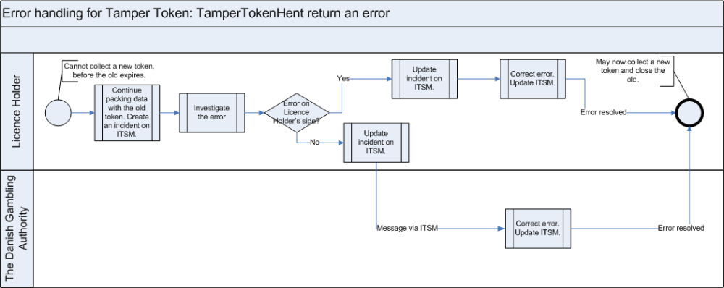

Process description
The start condition of the process is the situation, where a Licence Holder cannot collect a new token, before the token, which already is in use, expires.

The Licence Holder should continue to pack data with the old token, even though this token cannot be closed on time. The Licence Holder must inform the DGA, if the token cannot be closed before it expires.

The Licence Holder investigates whether or not they can correct the error themselves, or if there is an error on the DGA’s side. The Licence Holder informs the DGA, when it has been identified whether the error is on the Licence Holders side or the DGA’s side.

If the error is on the Licence Holder’s side, the Licence Holder must correct the error.

If the error is on the DGA’s side, the DGA will correct the error.

The Licence Holder may now collect a new token and close the old token immediately hereafter.

Error handling for Tamper Token Luk serivce
Below is an illustration of the process for handling errors on TamperTokenLuk.
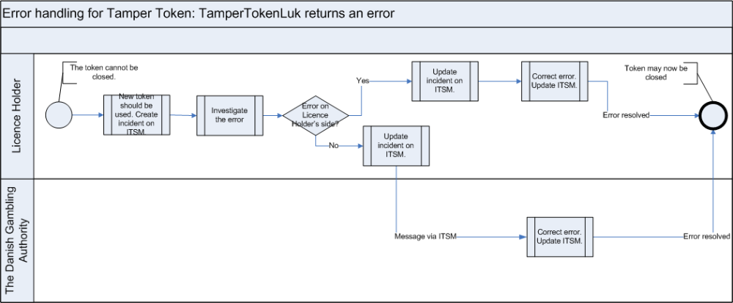

Process description
The start condition of the process is the situation where a Licence Holder cannot close the token on time before it expires.

At this point in the process, the Licence Holder will have collected a new token, since a new token must be collected before closing the existing. The Licence Holder should use the new token during the error handling process for TamperTokenLuk.

The Licence Holder should inform the DGA about the error on TamperTokenLuk.

The Licence Holder investigates whether or not they can correct the error on their side, or whether or not the error is on the DGA’s side.

If the error is on the Licence Holder’s side, the Licence Holder must correct the error.

If the error is on the DGA’s side, the DGA will correct the error.

The Licence Holder may now close the token.

Mechanism for MAC generation
The Licence Holder must build a mechanism to generate a MAC in the right way. It must match the way the Gambling Authority has built the same mechanism to ensure that MACs later can be compared. In the following sections it is described how to build this mechanism to generate MAC, including which API to apply.

The process for the mechanism that generates the MAC for a token is illustrated in the figure in section 4.3.5.

The 5 points on the figure are described in the following:
Ad 1. License Holder activates the service operation TamperTokenHent and receives a new TamperTokenID and a key, Key, which must be used for MAC generation for the first Standard Record file for the new Token.
Ad 2. When a new Standard Record file is generated, a MAC is generated of this record immediately after.
Ad 3. The generated MAC is now the new Key for the MAC generation.
Ad 4. After the MAC generation the present Standard Record file is added to a zip-file for the present token.
Ad 5. When a token is closed, typically after the time interval which is given in the response from the service operation TamperTokenHent, the service operation TamperTokenLuk is activated with ID for the Token which should be closed, the latest generated MAC and the identification of the License Holder.

MAC API
For generation of MACs the class SecretKeySpec from Java 1.6 must be applied. Below is presented an example of how the code can look for the step “Generate MAC for Standard Record file using KEY”.

The example uses the class ByteArrayHandler, which can be found on the Danish Gambling Authority’s website.

Documents and files
ByteArrayHandler.java

The argument key is the key and InputStream contains the data from a Standard Record, for which to generate a MAC.

Example:
public String getMAC(String key, InputStream input) throws TamperTokenException {
try {
Mac mac = Mac.getInstance("HmacSHA256");
byte[] byteKey = ByteArrayHandler.parseString(key);
SecretKeySpec keySpec = new SecretKeySpec(byteKey, "HmacSHA256");
mac.init(keySpec);
byte[] data = new byte[1024];
int read;
while((read=input.read(data)) > -1){
mac.update(data, 0, read);
}
return ByteArrayHandler.toString(mac.doFinal());
}
catch (Exception e) {
throw new TamperTokenException(e);
}
}

MAC algorithm – figure

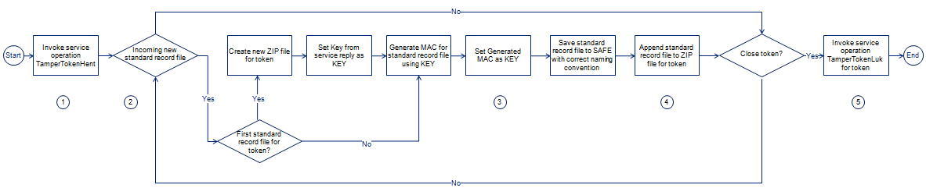

Example of MAC calculation
On the website of the DGA, there is a link to the folder “Vejledning”: http://85.81.229.78/projects/SPIL/Vejledning/. In this folder is placed a file called TamperTokenTest3-2152.zip, which has been used below to give an example of calculation of MAC.

Documents and files
TamperTokenTest3-2152.zip

The example has been made for SpilCertifikatIdentifikation = TamperTokenTest3 and TamperTokenID = 2152.

The file TamperTokenTest3-2152.zip contains three files: TamperTokenTest3-2152-1.txt, TamperTokenTest3-2152-2.txt and TamperTokenTest3-2152-E.txt. A start MAC is retrieved by the serviceoperation TamperToeknHent, and it is shown below as TamperTokenStartMAC. Following this are shown the intermediate MACs, which is calculated on each file. The MAC from the last file is reported by the serviceopeartion TamperTokenLuk in the element TamperTokenMAC.

TamperTokenStartMAC = fb99919c20c57b01a1ab37fdc576f75a

MAC of file TamperTokenTest3-2152-1.txt = 148f1bc4bfe2be67cfed691f6a703ed90e780f45faab665b5c86a3c8346ad056

MAC of file TamperTokenTest3-2152-2.txt = a79953be54a71069a07d2d7c63566daaab221de984d93c36ae8c7b26d149df90

MAC of file TamperTokenTest3-2152-E.txt = 1b14a1da76568ab3b96bc64bb7ee02e846fbd7711e3ce40f477b0c66a0663016

TamperTokenMAC = 1b14a1da76568ab3b96bc64bb7ee02e846fbd7711e3ce40f477b0c66a0663016

Handling unused tokens
In the case where Licence Holder has used the service TamperTokenHent to retrieve a token, and it later appears that the token should not be used anyway, the Licence Holder may close this token again by using the service eoperation TamperTokenLuk and let the field TamperTokenMAC (which normally contains the calculated MAC) contain the string ”empty”. Such a service request will look as follows:

<soapenv:Envelope xmlns:soapenv="http://schemas.xmlsoap.org/soap/envelope/" xmlns:ns="http://skat.dk/begrebsmodel/2009/01/15/">
<soapenv:Header/>
<soapenv:Body>
<ns:TamperTokenAnvend_I>
<ns:Kontekst>
<ns1:HovedOplysninger xmlns:ns1="http://skat.dk/begrebsmodel/xml/schemas/kontekst/2007/05/31/">
<ns1:TransaktionsID>895ffb40-9f4a-11e0-8264-0800200c9a66</ns1:TransaktionsID>
<ns1:TransaktionsTid>2011-10-15T18:41:30.054+01:00</ns1:TransaktionsTid>
</ns1:HovedOplysninger>
</ns:Kontekst>
<ns:TamperOperationValg>
<ns:TamperTokenLuk>
<ns:TamperTokenID>2112</ns:TamperTokenID>
<ns:SpilCertifikatIdentifikation>TamperTokenTest3</ns:SpilCertifikatIdentifikation>
<ns:TamperTokenMAC>empty</ns:TamperTokenMAC>
</ns:TamperTokenLuk>
</ns:TamperOperationValg>
</ns:TamperTokenAnvend_I>
</soapenv:Body>
</soapenv:Envelope>

This way of handling unused tokens gives the Licence Holder the possibility for parallel SAFEs, such that the Licence Holder may retrieve two tokens in parallel and use one for the primary SAFE and the other for the secondary SAFE. The secondary token will only be used in the case where an error occurs on the primary SAFE, however, the Licence Holder must still remember to close the token before it expires.

Examples of Tamper Token service request and reponse

In the following are presented examples of service requests and responses for the services which the Licence Holder must use. The examples are thought of as help for the Licence Holder to understand the services to be used, but it is not the intention that the Licence Holder should build code based on the examples. For this purpose is referred to the service descriptions, XSD schemas and WSDL-files which are found the the DGA’s website.

TamperTokenHent

Request:
<soapenv:Envelope xmlns:soapenv="http://schemas.xmlsoap.org/soap/envelope/" xmlns:ns="http://skat.dk/begrebsmodel/2009/01/15/">
<soapenv:Header/>
<soapenv:Body>
<ns:TamperTokenAnvend_I>
<ns:Kontekst>
<ns1:HovedOplysninger xmlns:ns1="http://skat.dk/begrebsmodel/xml/schemas/kontekst/2007/05/31/">
<ns1:TransaktionsID>895ffb40-9f4a-11e0-8264-0800200c9a66</ns1:TransaktionsID>
<ns1:TransaktionsTid>2011-06-25T18:41:30.054+01:00</ns1:TransaktionsTid>
</ns1:HovedOplysninger>
</ns:Kontekst>
<ns:TamperOperationValg>
<ns:TamperTokenHent>
<ns:SpilCertifikatIdentifikation>TamperTokenTest3</ns:SpilCertifikatIdentifikation>
</ns:TamperTokenHent>
</ns:TamperOperationValg>
</ns:TamperTokenAnvend_I>
</soapenv:Body>
</soapenv:Envelope>

Response:
<env:Envelope xmlns:env="http://schemas.xmlsoap.org/soap/envelope/">
<env:Header/>
<env:Body>
<ns:TamperTokenAnvend_O xmlns:ns="http://skat.dk/begrebsmodel/2009/01/15/">
<ns:Kontekst>
<HovedOplysningerSvar xmlns="http://skat.dk/begrebsmodel/xml/schemas/kontekst/2007/05/31/">
<TransaktionsID>895ffb40-9f4a-11e0-8264-0800200c9a66</TransaktionsID>
<ServiceID>TamperTokenAnvendService</ServiceID>
<TransaktionsTid>2011-06-25T18:41:30.054+01:00</TransaktionsTid>
</HovedOplysningerSvar>
</ns:Kontekst>
<ns:TamperTokenHent_O>
<ns:TamperTokenID>385</ns:TamperTokenID>
<ns:TamperTokenStartMAC>a06174fd062bb397894860bd5c20aa08</ns:TamperTokenStartMAC>
<ns:TamperTokenUdstedelseDatoTid>2011-06-25T18:47:04.481+02:00</ns:TamperTokenUdstedelseDatoTid>
<ns:TamperTokenPlanlagtLukketDatoTid>2011-06-26T18:47:04.481+02:00</ns:TamperTokenPlanlagtLukketDatoTid>
</ns:TamperTokenHent_O>
</ns:TamperTokenAnvend_O>
</env:Body>
</env:Envelope>

TamperTokenLuk

Request:
<soapenv:Envelope xmlns:soapenv="http://schemas.xmlsoap.org/soap/envelope/" xmlns:ns="http://skat.dk/begrebsmodel/2009/01/15/">
<soapenv:Header/>
<soapenv:Body>
<ns:TamperTokenAnvend_I>
<ns:Kontekst>
<ns1:HovedOplysninger xmlns:ns1="http://skat.dk/begrebsmodel/xml/schemas/kontekst/2007/05/31/">
<ns1:TransaktionsID>895ffb40-9f4a-11e0-8264-0800200c9a66</ns1:TransaktionsID>
<ns1:TransaktionsTid>2011-06-25T18:41:30.054+01:00</ns1:TransaktionsTid>
</ns1:HovedOplysninger>
</ns:Kontekst>
<ns:TamperOperationValg>
<ns:TamperTokenLuk>
<ns:TamperTokenID>385</ns:TamperTokenID>
<ns:SpilCertifikatIdentifikation>TamperTokenTest3</ns:SpilCertifikatIdentifikation>
<ns:TamperTokenMAC>2da9fe732840bc40f05eefbace7bf03fc36e141907a8d6ce7da329fa0f1bb25c
</ns:TamperTokenMAC>
</ns:TamperTokenLuk>
</ns:TamperOperationValg>
</ns:TamperTokenAnvend_I>
</soapenv:Body>
</soapenv:Envelope>

Response:
<env:Envelope xmlns:env="http://schemas.xmlsoap.org/soap/envelope/">
<env:Header/>
<env:Body>
<ns:TamperTokenAnvend_O xmlns:ns="http://skat.dk/begrebsmodel/2009/01/15/">
<ns:Kontekst>
<HovedOplysningerSvar xmlns="http://skat.dk/begrebsmodel/xml/schemas/kontekst/2007/05/31/">
<TransaktionsID>895ffb40-9f4a-11e0-8264-0800200c9a66</TransaktionsID>
<ServiceID>TamperTokenAnvendService</ServiceID>
<TransaktionsTid>2011-06-25T18:41:30.054+01:00</TransaktionsTid>
<SvarReaktion>
<Advis>
<AdvisNummer>0</AdvisNummer>
<AdvisTekst>Token is now closed</AdvisTekst>
<ServiceID>TamperTokenAnvendService</ServiceID>
</Advis>
</SvarReaktion>
</HovedOplysningerSvar>
</ns:Kontekst>
</ns:TamperTokenAnvend_O>
</env:Body>
</env:Envelope>

Licence Holder’s quality assurance

It is the responsibility of the Licence Holder to ensure compliance with all technical requirements. This section describes two areas which Licence Holder must be particulary aware of. In section 5.1 it is described how Licence Holder can ensure that the generated Standard Records schema validates agains the by the DGA specified schemas for Standard Records. In section 5.2 it is described how Licence Holder must ensure that the Tamper Token MAC is calculated correctly.

Schema validation of Standard Records with XML Spy

The Licence Holder is obliged to ensure that the reported data are schema valid. Schema validation can be tested by the Licence Holder by using the program XML Spy as follows:

- Download and install XML Spy.
  - Download a fully functional free 30-day trial version of Altova XMLSpy 2012 (http://www.altova.com/download/xmlspy/xml_editor_enterprise.html)
- Download XML-schema files from the DGA’s website.
  - See section 2.2 for reference to file name.
  - Unzip.
- Start a new project in XML-Spy.
  - Use Explorer to pull your unzipped XML schema files in to “DTD/Schemas” folder in the Project navigation tab.
- You are now ready to validate a file.
  - Open the XML file in XML Spy.
  - Assign the schema to the file.
    - Choose the menu DTD/Schema, option 2 – Assign Schema.
    - Choose “OK”.
    - Choos window.
    - Choose the correct XSD file from the list.
    - Choose “OK”, “OK”, “OK” (3 times).
    - Choose F8 to validate your XML file, the result will be presented in the Messages window.
- Correct any errors and make sure that all XML files are valid before upload to SAFE.

Validation of correct Tamper Token MAC calculation

It is important that the Tamper Token MAC code is calculated correctly. Licence Holder must ensure that if the MAC code of a zip-file which the Licence Holder has placed on SAFE is calculated, the value must match the value which Licence Holder has reported to the Tamper Token system.
Licence Holder must perform a thorough test and ensures that the reported MAC also corresponds to the MAC which can be calculated from the file.

Tool for validating standard records

On the Danish Gambling Authority’s website is a tool available for validation of standard records. The tool can be applied for both manual and automatic schema validation of standard records. The tool can be found on the following address: http://85.81.229.78/projects/SPIL/KasinoSpilleautomater/StandardRecordValidatorTool-2.0/. A file describing how to use the tool is also available in the folder.

Licence Holder must implement the tool as an automatic quality assurance of the standard records placed on SAFE, such that any data which is not schema valid will be found by Licence Holder before sending the data to the Danish Gambling Authorithy.

